**Zennor Asset Management   
ACTIVE OWNERSHIP REPORT   
H1 2022**

1. **VOTING BEHAVIOR**
2. **Voting behaviour**

Zennor believes that voting is one of the fundamental responsibilities of stewardship. It is an opportunity to formally support the management or not to support their policy. In Japan even modest levels of non-support can be sufficient to drive an internal reassessment.

These details are provided in the charts attached.

We have voted all our positions - 28 out of 28 securities where there were votes. There were a total of 315 management and shareholder proposals. We did not support management on 36 of 308 management proposals and supported 3 of 7 shareholder proposals. In total there were 315 proposals and we voted against 39 of them. We Abstained on one vote which had been withdrawn by the proposer.

Looking explicitly at voting against management, our most frequent area of concern that we express through voting is with Board level governance – usually double hatting, and independence of directors. This is one area where we are often aligned with other shareholder proposals. M&A – with poorly specified or unchallenging targets is another area of ongoing frustration. There was only one explicitly environmental vote in which we did not support a poorly conceived shareholder proposal – in line with our proxy advisory recommendation.

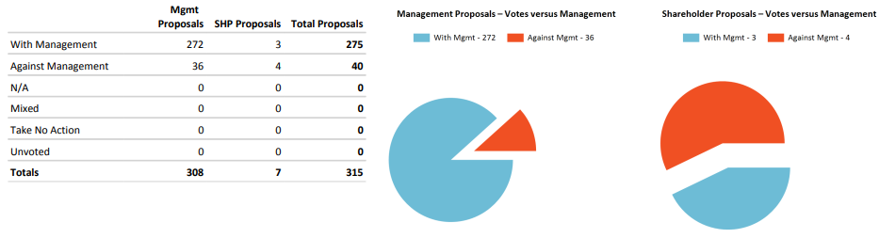

The overwhelming majority of votes are about approval of financial reports and appointment of directors. The number of expressly Environmental (0) or Social (0) proposals was very low!

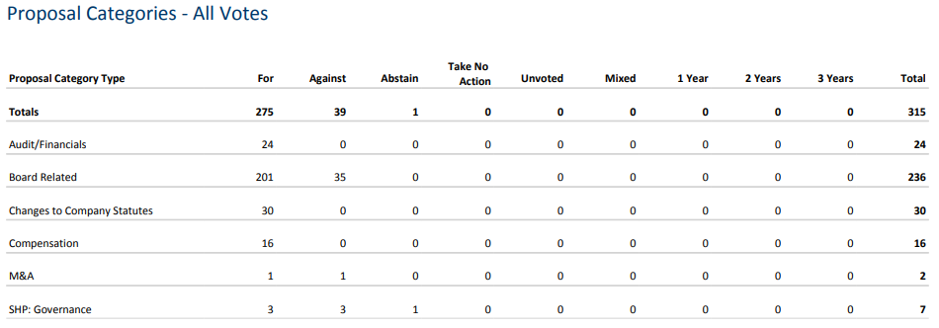

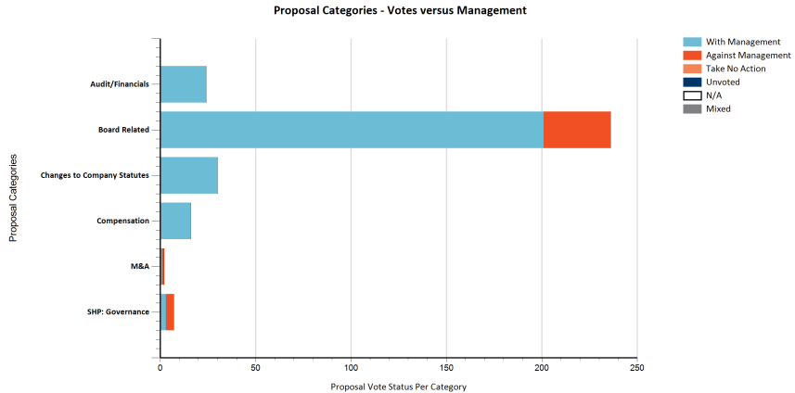

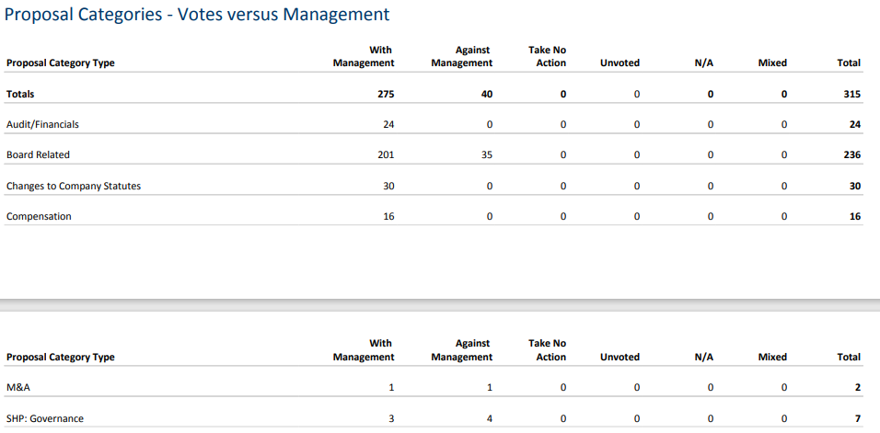

1. **Involvement of the fund management team in the decision how to vote.**

The votes are always decided by the fund management team on an individual case by case basis in line with our voting principles. We voted against the recommendation of our Proxy Company 12 times. 11 of these relate to the board and 1 to Governance. Often their rules-based systems neglect the specifics of the situation – or where we feel continued constructive engagement by supporting management could be more effective. In general, we do not disagree with their principles but rather the application.

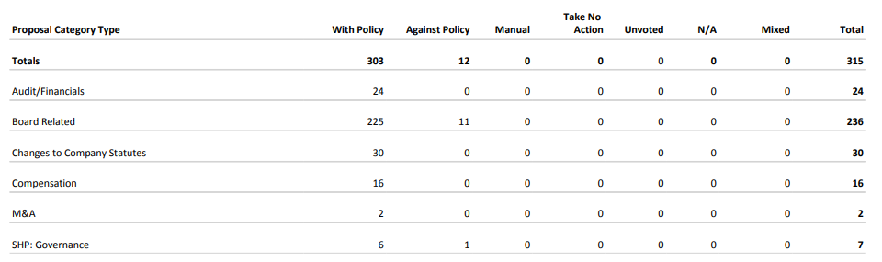

1. **ESG TRANSPARENCY, ANALYSIS AND ENGAGEMENT**

The nature of our focus on very undervalued, under researched companies, it usually means that engagement of some kind is required to help unlock the value that we see. Consequently, a very high percentage of our portfolio is subject to engagement on governance, operational performance, and sustainability (ESG). The ongoing revolution in Corporate Governance in Japan is coincidental with the global focus on Sustainability. Frequently, these go hand in hand. Without good governance we do not believe that a company can ever be sustainable, so this remains a critical focus for us. One of our key objectives is to work with management teams and to help them think and act like owners of the business – oriented towards long run, per share value creation – for us this is consistent with good Sustainability. We keep track of these activities in our Engagement Tracker.

This chart shows the breakdown by primary engagement focus for each meeting. Strategy is an operating focus; whilst Governance captures Board activity, corporate culture, and balance sheet reform; Environmental is more than just carbon focused but this is a focus area of interaction with companies for us.

Zennor has had circa 74 contacts regarding investments or potential investments over the period under review. We have had calls and contacts with companies beyond this that are not rated as being specifically targeted ‘engagements’ but where we also look at Sustainability in those meetings. We do not usually record contact with analysts as engagements although this can sometimes be a ‘back channel’ to companies and a way of understanding other investor concerns.

We have been very engaged with several stocks where governance remains a challenge notably Toshiba and Fujitec. In Toshiba’s case the management team has allowed several private equity firms interested in a take private deal detailed access to their books. These 4 groups are expected to make their proposals – if any this autumn. This is the result of concerted engagement by investors with the company and the board – ironically it is shareholders who feel that the company is being too short term. Secondly, we have engaged with Fujitec. This culminated in the founding family member CEO deciding (at the last minute) not to stand for re-election to the board. The new board then appointed him non-executive, non-board member Chairman of the company. Clearly much more work needs to be done to realise the value and reform the culture inside the company. This is what we really mean when we talk about governance. In Japan the question of in whose interest cash flows and balance sheets are utilised remains a still contested issue.

Those companies making progress include T Hasegawa and BeNext Yumeshin both of whom are releasing updated CSR disclosures in the autumn. Orix has now published its ESG data but this is not yet reflected in databases. We introduced them to some of the data providers to ensure that the format they were using was appropriate. One new holding Nippon Soda which already has some good areas of qualitative disclosure will be completing the CPD reporting for the first time this year after we explained how important this information was for investors and their clients.

We have also recently completed our annual carbon intensity study. This is a very granular study using all of the different data sources at our disposal. The quality of data is improving but still not very good. We also use this to compare some of the data vendor estimation of our footprint. The Scope 1 / 2 carbon intensity that we estimate is 41 Tco2/$1m revenue.



Contrasting this with the estimates from 3 data vendors shows a Scope 1 estimation gap of 6.5x. One main difference between our estimate is that we spoke to several companies who have not yet officially released their data and incorporated this ‘best efforts estimate’ which those data providers do not have access to. Our portfolio estimate is very close to that derived by Bloomberg and Vendor A after making those adjustments. In contrast Vendor B estimation is quite far removed. For reference Topix is reported to be an intensity of 91 on an equivalent basis by Bloomberg.

