Zennor Asset Management
ACTIVE OWNERSHIP REPORT
H2 2021

- VOTING BEHAVIOR

- Voting behaviour
Zennor believes that voting is one of the fundamental responsibilities of stewardship. It is an opportunity to formally support the management or not to support their policy. In Japan even modest levels of non-support can be sufficient to drive an internal reassessment.
These details are provided in the charts attached.
We have voted all our positions - 29 out of 29 securities. There were a total of 326 management and shareholder proposals. We did not support management on 25 of 317 management proposals and supported 4 of 9 shareholder proposals. In total there were 326 proposals and we voted against 30 of them. Abstained on none.
Looking explicitly at voting against management, our most frequent area of concern that we express through voting is with Board level governance – usually double hatting, and independence of directors. Compensation – with poorly specified or unchallenging targets is another area of ongoing frustration. There was only one explicitly environmental vote in which we did not support a poorly conceived shareholder proposal – in line with our proxy advisory recommendation.
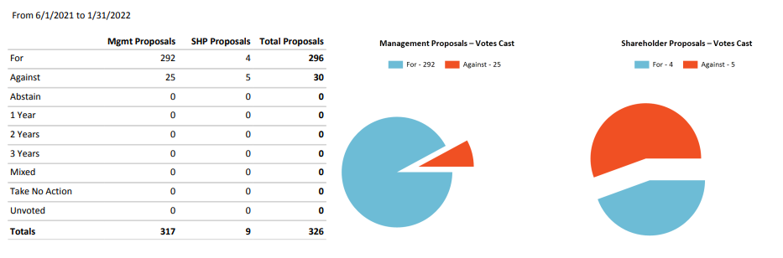
The overwhelming majority of votes are about approval of financial reports and appointment of directors. The number of expressly Environmental (1) or Social (0) proposals was very low.

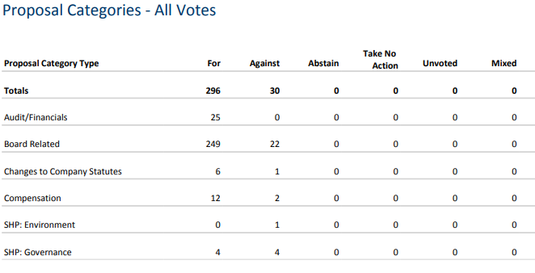
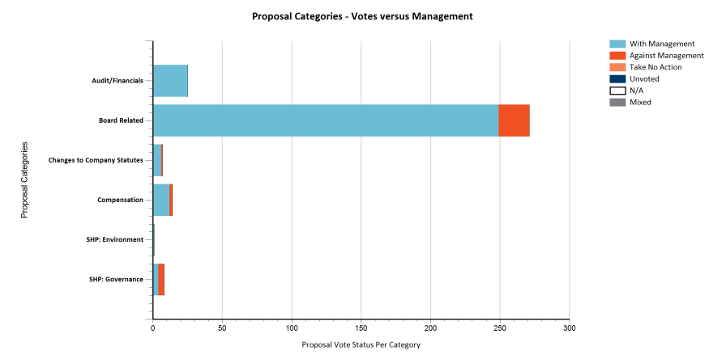
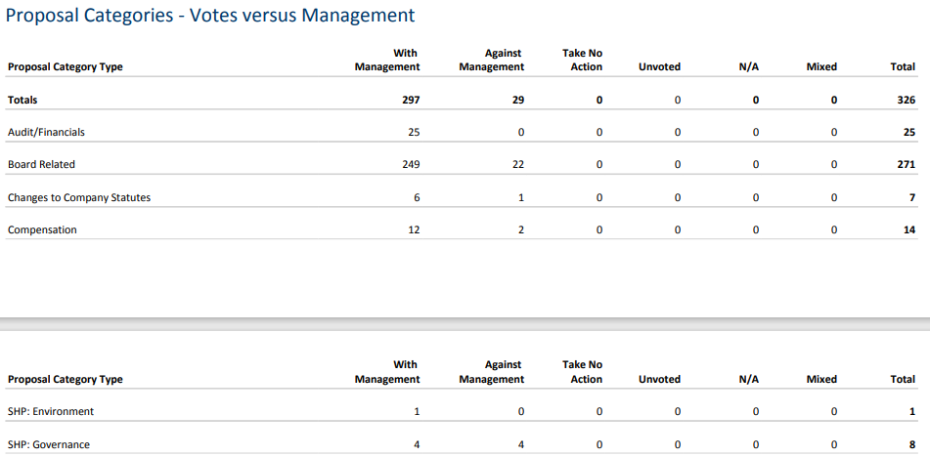
- Involvement of the fund management team in the decision how to vote.
The votes are always decided by the fund management team on an individual case by case basis in line with our voting principles. We voted against the recommendation of our Proxy Company 9 times. 6 of these relate to the board and 3 to Governance. Often their rules-based systems neglect the specifics of the situation – or where we feel continued constructive engagement by supporting management could be more effective. In general, we do not disagree with their principles but rather the application.
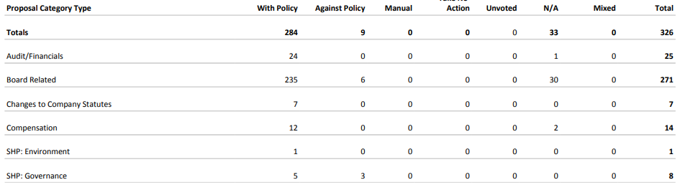

- ESG TRANSPARENCY, ANALYSIS AND ENGAGEMENT

The nature of our focus on very undervalued, under researched companies, it usually means that engagement of some kind is required to help unlock the value that we see. Consequently, a very high percentage of our portfolio is subject to engagement on governance, operational performance, and sustainability (ESG). The ongoing revolution in Corporate Governance in Japan is coincidental with the global focus on Sustainability. Frequently, these go hand in hand. Without good governance we do not believe that a company can ever be sustainable, so this remains a critical focus for us. One of our key objectives is to work with management teams and to help them think and act like owners of the business – oriented towards long run, per share value creation – for us this is consistent with good Sustainability. We keep track of these activities in our Engagement Tracker.

This chart shows the breakdown by primary engagement focus for each meeting. Strategy is an operating focus; whilst Governance captures Board activity, corporate culture, and balance sheet reform; Environmental is more than just carbon focused but this is a focus area of interaction with companies for us.

Zennor has had circa 60 contacts regarding investments or potential investments over the period under review. We have had calls and contacts with companies beyond this that are not rated as being specifically targeted ‘engagements’ but where we also look at Sustainability in those meetings. We do not usually record contact with analysts as engagements although this can sometimes be a ‘back channel’ to companies and a way of understanding other investor concerns.

One case where we have had impact is at Orix. Zennor’s vision was presented to the CEO and operating division managers. Our thesis that they should shift their business model towards a capital light strategy resonates with many senior members of the leadership team. We also asked them to improve their Sustainability disclosure and to better highlight their Renewable Energy business (previously scattered across several divisions). Historically, their governance structure was good, but their sustainability reporting and strategy explanation has been poor. In the last 6 months they have released an updated Sustainability strategy and will be increasing their reporting from now onwards. The shift from adoption of qualitative UNSDGs to a more quantitative Sustainability reporting framework is one that many Japanese firms are moving through and is clearly visible at Orix. In many cases we see firms that are directionally DOING the right things but have not yet developed the appropriate reporting frameworks. Orix has started to disclose using TCFD measures from 2020 as a first step in this direction.

To get a sense of how things are changing for the better I have included Orix’s-:

Sustainability Report for 2019 – with a UNSDG orientation and poor quantitative disclosures. They explicitly acknowledge many of the Environmental, Social and Governance issues but provide limited data.
https://www.orix.co.jp/grp/en/pdf/sustainability/sustainability_report/SR2019E.pdf#:~:text=ORIX operates in a wide range of businesses%2C, Managing risk is also part of sustainability.
Sustainability Report for 2021 which includes specific CO2 reduction goals; 50% board independence and diversity targets; a net carbon zero 2050 target; and scenario analysis on <4/<2-degree targets for key divisions. Orix has also expanded their analysis downstream to their Scope3 impact. Quantitative data granularity is much higher. Additionally, they now have an independent external environmental audit by KPMG. Finally, on the Social aspects they have materially fleshed out their policies on Diversity, Compliance, Data Security, Modern Slavery and Whistleblowing.
https://www.orix.co.jp/grp/en/pdf/sustainability/sustainability_report/SR2021E.pdf
Their data reporting has also been substantially increased and will continue to improve.
Sustainability-Related Policies and Data | ORIX Group
They held an ESG focused IR day and virtual roadshows alongside their first half results to showcase the new policies to investors.
https://www.orix.co.jp/grp/en/pdf/ir/library/presentation/Presentation_2022_2QE.pdf
Orix may still have some way to go but very significant progress is clearly being made in terms of activity and reporting. Remarkably because much of the new data is not yet available on annual assessment basis as result some third-party Sustainability ratings still rank them poorly. The Bloomberg ESG score is just 35.5/100 as the new data has not yet filtered through. CDP scores them 2/8. However, ISS scores them 1 for governance. MSCI (AA), S&P (69) and Sustainalytics (28.4) scores are class leading in Japanese non-bank financials whilst still having some scope for improved absolute scores.
We have also spoken to Orix about their capital allocation and especially the high cost of principal capital. We have encouraged them to sell down some assets and recycle that in a more efficient manner. Given the low valuation and strong capital position we have also been pushing for enhanced shareholder return. Following the sale of some Private Equity assets in the US and Japan Orix has begun a meaningful buyback and raised the dividend.

Further instances where our views have been heard is at Nishimatsu Construction – 28% buyback; at JAFCO executed on their 25% buyback following the excess NRI stake disposal; Hi-Lex which has conducted several small buybacks; and T Hasegawa that has begun reducing its investment portfolio, has acquired several assets in the US and begun a buyback program. Over the course of the period February 2021 to YE2021 we saw 6 companies in our portfolio get taken over, bid for or have a very meaningful capital return. Our holding Benext Yumeshin also introduced a new Sustainability strategy that represented a substantial improvement on the previous policies and disclosures that they had. We had spoken to the senior leadership team several times about their poor quantitative disclosure, and this should now improve.

