Zennor Asset Management
ACTIVE OWNERSHIP REPORT
H2 2022

- VOTING BEHAVIOR

- Voting behaviour
Zennor believes that voting is one of the fundamental responsibilities of stewardship. It is an opportunity to formally support the management or not to support their policy. In Japan even modest levels of non-support can be sufficient to drive an internal reassessment.
These details are provided in the charts attached.
We have voted all our positions. Typically, most Japanese companies have their AGM in H1 and so relatively few (4) proxy events occurred.
Looking explicitly at voting against management, our most frequent area of concern that we express through voting is with Board level governance – usually double hatting, and independence of directors. This is one area where we are often aligned with other shareholder proposals. In this reporting period we voted against one manager due to his double hatting.
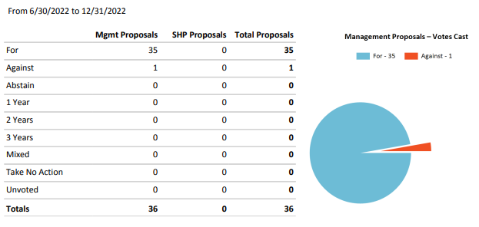

The overwhelming majority of votes are about approval of financial reports and appointment of directors. The number of expressly Environmental (0) or Social (0) proposals was very low!
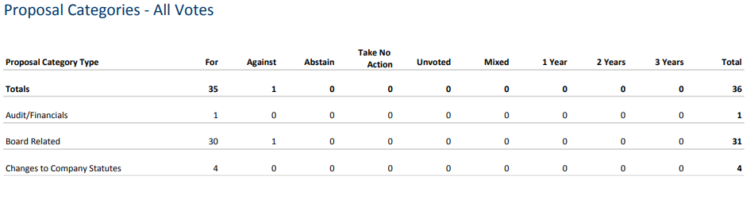
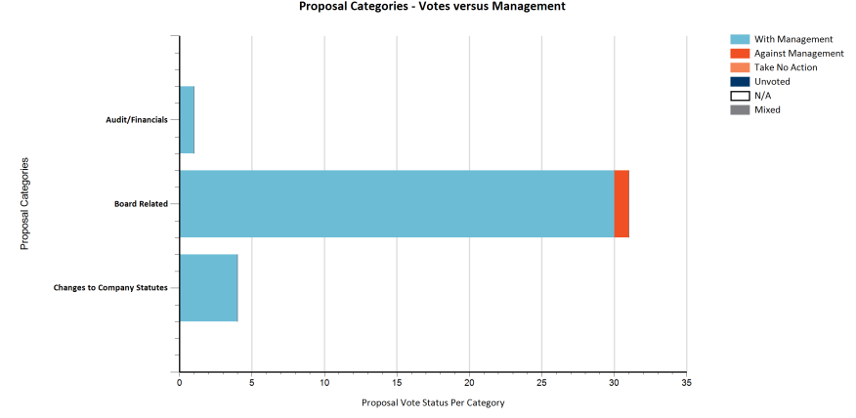
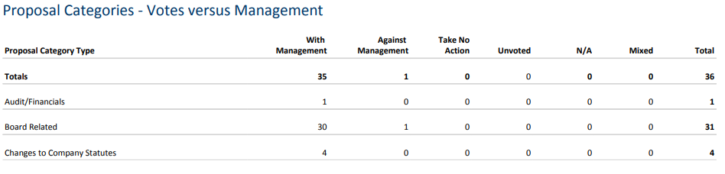

- Involvement of the fund management team in the decision how to vote.
The votes are always decided by the fund management team on an individual case by case basis in line with our voting principles. We voted against the recommendation of our Proxy Company 0 times. This is not always the case as we frequently differ in our implementation of governance. Often their rules-based systems neglect the specifics of the situation – or where we feel continued constructive engagement by supporting management could be more effective. In general, we do not disagree with their principles but rather the application.
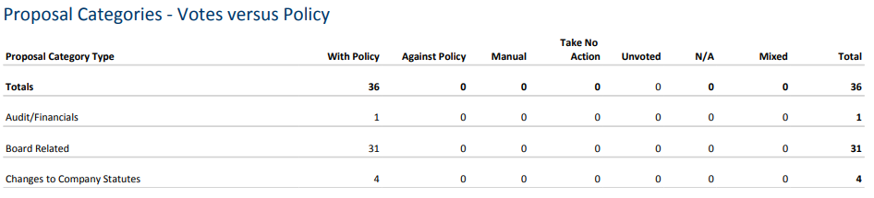

- ESG TRANSPARENCY, ANALYSIS AND ENGAGEMENT

The nature of our focus on very undervalued, under researched companies, it usually means that engagement of some kind is required to help unlock the value that we see. Consequently, a very high percentage of our portfolio is subject to engagement on governance, operational performance, and sustainability (ESG). The ongoing revolution in Corporate Governance in Japan is coincidental with the global focus on Sustainability. Frequently, these go hand in hand. Without good governance we do not believe that a company can ever be sustainable, so this remains a critical focus for us. One of our key objectives is to work with management teams and to help them think and act like owners of the business – oriented towards long run, per share value creation – for us this is consistent with good Sustainability. We keep track of these activities in our Engagement Tracker.

This chart shows the breakdown by primary engagement focus for each meeting. Strategy is an operating focus; whilst Governance captures Board activity, corporate culture, and balance sheet reform; Sustainability is more than just carbon focused but this is a focus area of interaction with companies for us.

Zennor has had 59 engagement contacts regarding investments or potential investments over the period under review. We have had calls and contacts with companies beyond this that are not rated as being specifically targeted ‘engagements’ but where we also look at Sustainability in those meetings. We do not usually record contact with analysts as engagements although this can sometimes be a ‘back channel’ to companies and a way of understanding other investor concerns.

We have been very engaged with several stocks where governance remains a challenge notably Toyo Construction. In Toyo’s case we wrote to the board of directors to express our concern about their process for handling a potential tender offer which is very weak and where we were concerned that Directors were being excluded by the management team. Subsequently they have started a Special Committee to examine the proposal. Clearly much more work needs to be done to realise the value and reform the culture inside the company. This is what we really mean when we talk about governance. In Japan the question of in whose interest cash flows and balance sheets are utilised remains a still contested issue.

We have seen good progress in reporting by Nippon Soda who released their inaugural Integrated Report. They will be completing the CPD reporting for the first time this year after we explained how important this information was for investors and their clients. We have also seen increased reporting by holding TSI who is now bringing out Scope1 and 2 analysis and is committed to increasing disclosure. Finally, we have begun engagement on a range of areas with Transcosmos and Fukushima Galilei. Both firms are eager for input following a change in management generation. In general, the pressure for companies with high cross-shareholdings to cut them or face votes against senior management is proving quite effective at encouraging change. Working with management rather than against them is both more enjoyable and more fruitful.

Further examples of engagement are provided in the below table:
Date | Company | Level | Engagement Points | Outcome
Q4 | Fukushima Galilei | Management, COO | Contact re-initiated. Follow up(s) on Carbon disclosure, governance, and capital policy! | Fukushima Galilei is a well invested industrial refrigeration company with top market share amongst large users. Family run it has high margins and cash flow but has been inward looking. A generation transition is happening offering a chance to re-appraise. We wrote to and then presented to the company on our thoughts about what they could and should do to elevate performance and disclosures.  We spoke to them about the lack of independent goverance on their board and how this had led to them not having best practice and meaningful extrenal feedback. The capital allocation strategy was inadequate and the company had a very large balance sheet compared to our assessment of operating needs. With the new TSE guidelines this was useful feedback for them in terms of how investors analysed their cost of capital and returns and what the level of expectation was. Something that they had not received from investors before.  Their disclosures on sustainability were also very weak. We shared the data available from public sources and showed how their efforts were going unrecognised. His is despite the fact that their new products cut customer energy usage by >20%. As a consequence of this they have decided to particpate in CDP as a way to drive both better internal data collection and reporting and to ensure that their progress is better recognised by external sources.
Q3 | Nippon Soda | CEO | No Sustainability disclosure | Nisso is a leading agricultural chemical company in Japan with strong presence in Europe. Despite the high energy consumption of their business and its importance in broader food supply chains they had no sustainability disclosure at all. Whilst they have clearly followed many regulatory standards around production and safety their disclosure captured none of this data.  Having shared with them some disclosures from similar companies we suggested that they utilise internal data and make it more available to investors. We also highlighted that many of their customers would also require this data in time as a part of their own reporting and that it would be a source of competitive advantage to be able to meet their demands ahead of these timelines. The company responded impressively by publishing its first Corporate Social Responsibility document including quantitative metrics. Whilst not perfect it is an outstanding first step which they have promised to improve on further.
Q3 | TSI |  | Engagement on disclosure ahead of new MTP. Focus on Sourcing, labour rights and water impact | TSI is a leading Japanese apparel company. They are undergoing a revitalisation under a new management team and supported by Daiwa PE. The old TSI had many issues including a near total lack of sustainability disclosure. We explained that we as investors needed to understand much more about their sourcing and labour practices as well as issues of environmental impact such as water impact. Although their exposure to European retail is very small we also argued that the incoming regulations on sourcing would be followed in Japan and that they needed to strengthen their capabilities in terms of substantiating their sourcing – especially with regard to potentially high risk Chinese cotton and labour practices in SEAsia. We also suggested that although this is not yet a major factor for many Japanese consumers that it would likely become so and that those companies who had credibility in this area would be well placed. This is consistent with our suggestion that they elevate their brands and value proposition rather than compete at the lower end.  The company responded in their MTP which outlined their sustainability objectives, introduced TCFD reporting and saw a change in the board composition with the last remaining family member stepping down.
Q3/4 | Fujitec | Chairman, Board Members, Counsel, IR | Follow up on prior engagement. Very poor governance. | Follow up on prior engagement. Fujitec is an ongoing engagement where egregious acts by the previous management had led to their partial removal but where many senior executives still supported the old team. This manifested itself in obstruction of external counsel in investigating the previous team and in the reappointment in a non-board role of the old deposed CEO as Chairman. This is unacceptable to say the least.  We spoke to both members of the incumbent board and management to hear their views and with an engagement fund who were proposing a new slate of board candidates who they were nominating in an EGM. Whilst the new board move is very aggressive for Japan we could not support the incumbent board after they had aligned themselves so clearly against shareholders and with management. Consequently 4 o 5 new directors were elected and the board is adopting a robust approach to the incumbent/loyalist faction.
Q4 | Toyo Construction | Representative Director | Low performance culture. Governance. Letters and calls | We engaged with Toyo Construction after the management had repeatedly refused to negotiate with top shareholder YFO. We asked them to clarify their objections to the YFO suggestions on growth strategy centered around offshore wind power in Japan and civil engineering lifecycle extension. We also strongly requested that they address the issues of governance raised by YFO around their proposal which has been very superficial and limited to a formal application of process rather than meaningful engagement.  Our sense is that the board is captive to the management team and much more aligned to their long-term partner Infroneer. Whilst this is not ideal our conversations revealed that the firm has, under pressure, accepted that their previous strategy was unambitious, and engagement has altered their thinking around growth potential and capital allocation.  Engagement has had a positive outcome with dividends being material hiked, and a sound MTP plan announced. The outcome of an attempt to move away from a very low performance culture is welcome. We remain concerned that governance is insufficiently robust to control the assertive management team. Knowing them much better after repeated interactions we have chosen to exit with a healthy profit.

The current portfolio carbon footprint continues to be superior to that of the broad Japanese benchmark. Using Bloomberg data shown below. We believe that this likely overstates our Carbon exposure as the top contributor data is incorrect and the next two are both exposed to Copper production and we see them as enablers of the energy transition (mitigating at Scope3). We will be conducting our next granular bottom-up analysis over summer 2023. Based on ClarityAIs methodology this ranks 70/100 on their Carbon score. Their estimated Weighted Average Carbon Intensity/$ revenue is just 39. This intuitively fits more closely with our previous work.

Bloomberg Estimation
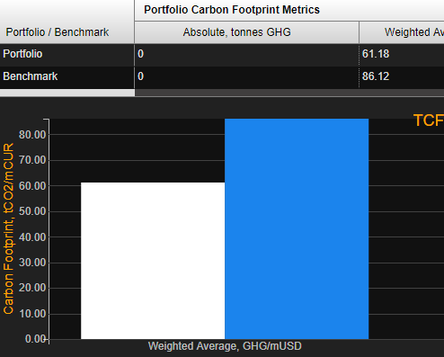
ClarityAI estimation
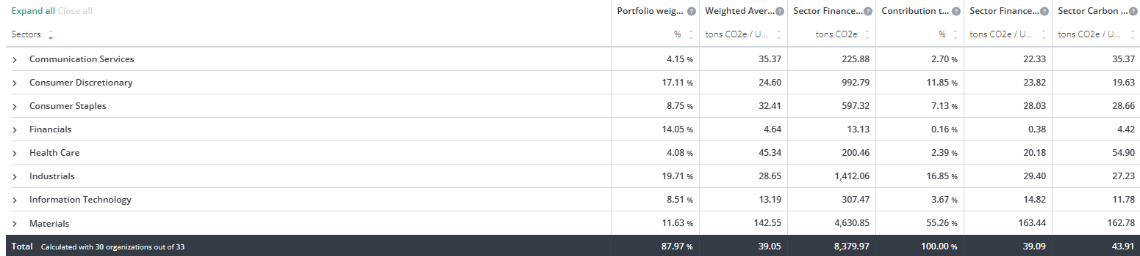

One notable change has been the integration of PAI analysis across all new positions. This is additional insight provides valuable information on risk and potential areas of concern. Alongside this enhanced process the fund has moved to an Article 8 status.

Looking at the SFDR reporting still requires a great deal of estimation and not all our holdings (especially new listings) are fully covered. However, the portfolio does not have exposure to UN Global Compact violators, Controversial Weapons or to Thermal Coal. This is monitored on an ongoing basis. Several areas of low scoring are due to the poor reporting of policies such as Modern Slavery, Human Rights, and Supplier Code of Conduct. Most, if not all, of these are covered by Japanese law and hence ‘not reported’ as a standalone policy YET. We are working with our investments to help them understand the importance of clearly setting out these policies and quantifying them if possible.

